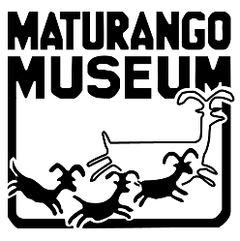
Maturango Museum of the Indian Wells Valley
100 E. Las Flores Ave, Ridgecrest, Ca. 93555 760-375-6900
Email info@maturango.org Website www.maturango.org

2nd Annual Matching Donation Drive, June 1 – Aug. 1, 2024
Donate by credit card online at: https://maturango.org/charitable-giving/

PLEASE PRINT
Donor Name __________________________________________________________________
Billing address __________________________________________________________________
City, ST., Zip Code ________________________________________________________________
Phone ___________________________________Email ________________________________
☐ I (we) wish to have our gift remain anonymous
Mark Gift Level for Matching Donation Drive
___ Desert Dandelion $100 - $249
___ Monkey Flower $250 - $499
___ Charlotte’s Phacelia $500 - $749
___ Goldfield $750 - $1000
___ Other $___________

MUSEUM USE
Date Received: _____________ Method: ☐cash ☐ credit card ☐ check #__________ By: _______________

