Volume 63, # 8 August 2025

Maturango Museum News
Preserve, interpret and develop an appreciation for
the natural and cultural history of the Northern Mojave Desert.

100 E. Las Flores Ave., Ridgecrest, CA 93555
Open Monday – Saturday 10 am – 5 pm, Sunday Noon – 4pm
760.375.6900 www.maturango.org
Death Valley Tourist Center Northern Mojave Visitor Center

Museum Director’s Notes
By Debbie Benson, Director

The summer night is like perfection of thought ~ Wallace Stevens

Thank you to all of the wonderful donors who took part in the Matching Funds drive! You make a difference and we know how important it is to have your care and support. Thank you also to our newest members. Welcome and enjoy your membership benefits!
The Museum is staying busy with travelers driving through town and local people just wanting to come in, get cool and look at the Gift Store and the Museum itself. Some of the Pacific Crest Trail hikers come to the Museum to look at the photo display in the Sylvia Winslow Gallery and see if they recognize the locations. It’s always interesting to share a conversation and learn that some have the trail as a part of their life goal where others just happened into it. It takes all kinds!
While we celebrate August, it is often the month of some of the hottest days. In Ridgecrest we have our fair share of hot days, which is what makes the evening and the night so enjoyable. The temperature drops as the sun sinks in our sky and we have a chance to just sit and admire our view of the surrounding mountains and enjoy the star-filled beauty of a summer night in the desert. It is even a pleasure to watch the evening bats flitting above, taking care of a fair amount of the summer bug population!

We are getting ready for the local schools to open the first week of August. Please watch for the traffic flow to reflect school activities.
Take care and remember to hydrate!

"Hidden Ridgecrest 5 – Video by Mark Pahuta
Sunday August 31, 2 pm.

The video will share some fun facts….
Did you know that the widening of China Lake Boulevard to 4 lanes in 1955 was one of Ridgecrest's largest community celebrations ever?
Did you know that on the north range of China Lake there exists a mysterious rock shelter that may or may not be a cavalry fort from the 1800s?
Did you know that most names in Ridgecrest come from several sources and that many like "Downs," "Crumbville," and "Peg," are named after people that either had nothing to do with the area, were misspelled, or were Red Mountain prostitutes?
These and other gripping questions will be answered in this 5th version of "Hidden Ridgecrest." Producers, Mark Pahuta and John Daly, will be on hand to introduce the video and to answer any questions after the screening. As usual the event is free, but seating is limited. The video runs about one hour.

Docent Doings
By Nora Nuckles, Education Coordinator

The owls have it! What? Docents gave a presentation to well over 60 people at the Ridgecrest Library in June. Participants learned about the owls that are in our desert. Dan and Brenda Burnett talked about the owls from the docent collection - the burrowing owl, the great horned owl, the barn owl, and the long-eared owl. Then visitors were given owl pellets, tweezers, and toothpicks; participants, both young and old, found the vertebrae, leg bones, and skulls of many small mammals and birds in the pellets. The pellets we use are ordered from a company that has sterilized and wrapped them in small foil packages. Participants are often surprised to learn that these pellets have been regurgitated by the owl after passing through two stomachs! We also took the owl presentation to High Desert Haven where several participants enjoyed dissecting the pellets.
We have been busy this summer with several tours and programs at the Ridgecrest and Trona libraries. We have presented 7 programs to about 280 people. At our free Saturday in July Bob Parker brought his baby tortoises and a larger tortoise strolled around the Coso Room. Visitors were able to decorate styrofoam tortoises that Bob Parker obtained from the Bureau of Land Management.

On August 9, our next Free Saturday, Shirley Crouse and other docents will present a program on desert safety in the heat. She will include a discussion about how desert animals adapt to surviving in the desert heat and what we as humans need to do to stay safe. There will be an activity to decorate sun visors and take one home!

Docents take some time off in the summer but may offer something special. Watch our website for details. We are always open to new people joining the docent ranks; call Nora at the Museum.

Maturango Museum “Call to Artists” for the Open Studio Tour 2025


The Maturango Museum is now accepting applications (due by August 17) from local artists for the Maturango Museum’s Open Studio Tour 2025. Artists open their studios for the 2-day event so guests can visit and purchase artwork. The tour will be Saturday and Sunday, September 27 & 28, 10 am – 4 pm each day. Each artist will also have a sample of their artwork displayed in the 2-month Open Studio Tour Exhibit (August 31 – Oct 27) at the Museum and be a part of the Artists’ Opening Reception (Sunday September 14, 2-4pm).
For information and applications please go to the museum (open 10 – 5 Monday - Saturday, Sunday noon – 4pm) or send an e-mail to Andrea gallery@maturango.org requesting Open Studio Tour information.
We have changed the application fee and commission procedures from last year(s). Please be sure to read the new procedures for 2025. The application fee is $100 for museum members and $140 for non-members, the commission for art in the gallery exhibit remains at 40% but there will be no commission for sales in your studios.

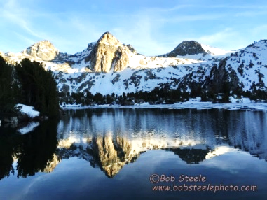
Pacific Crest Trail Photo Exhibit
April 21 – September 21

This 2,650-mile trail winds through some of the most inspiring and beautiful landscapes in the United States. It begins at the border of Mexico and leads backpackers through California, Oregon, and Washington, ending at the Canadian border. Or start in Washington and travel south to Mexico.
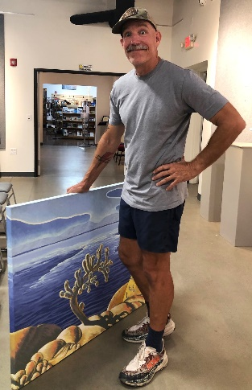
Warner Graves’ Art Exhibit: “Other Worlds”
This fantastic exhibit is in the Coso Room through August 24.

“The landscapes here have always been a source of inspiration for me,
my work reflects a deep connection to place and history.” Warner

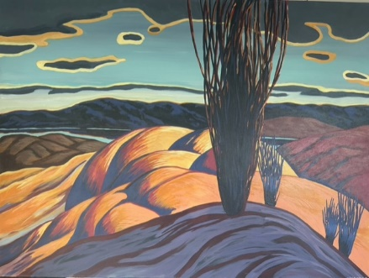
Warner Graves is an artist known for his contemporary take on the rugged beauty of the California desert. Using bold color, broad brush strokes, line and texture and reacting to intuitive impulses, the work unfolds as an exploration of the natural world and its lore. From a vintage stone cabin in Snow Creek, (a small secluded village at the foot of Mt. San Jacinto), Warner creates paintings of simplified and stylized forms to convey the monumentality and spiritual awe of the surrounding desert wilderness. The work is strongly rooted to the various locations in and around the arid regions of California and reflects interest ranging from historic travel posters, the natural sciences, hiking, and getting lost in the desert.
The playful use of color is a direct reference to the Canadian Group of Seven. Local early 20th century artist Agnes Pelton and her associated Taos School of Transcendental Art continues to be a source of inspiration. With the current series Warner hopes the viewer finds the beauty in the depiction of the desert environment but is also challenged to see the natural world not as a static form but as a living entity, imbued with vitality and flux.
A great article about Warner written in 2018. https://www.californiadesertart.com/the-golden-age-of-warner-graves-back-to-the-canyons/ His website is warnergraves.net

Recent Donations

Donations
Dan and Brenda Burnett
James and Barbara Herriman
Bill and Kathy Martin
Patricia Wharton
Ken Whetzel

In Honor of Rhodean Glen
Robert Glen

Building Fund
Robert Westbrook

Docents
AltaOne Federal Credit Union

Education
Margaret Hannon

Matching Funds Drive
Dan and Mary Anders
Elizabeth Babcock
Mark and Pat Backes
Peggy Breeden
Dr. Kristin H. Berry
Mike and Karen Brown
Robert and Bev Charlon
Blaise David for “The 4 Percent Wellness Challenge”
Bev Estis
Tom and Debra Fields
Ed and Carol Jeter
Robert Joy
Sharon Juarez
Michelle and Andrew
Kilikauskas
Penelope Le Pome
Pete and Renee Lesniak
Lori Markoff
Howard and Linda McCauley
Linda Miller Estate
David and Therese Moore
Susan Prazak
Anthony and Barbara Rice
John Smith
Gary Staab
Julie Stephens
Jim and Deanna Stewart
Elizabeth Swallow
James Thomas
Jim and Tammy Tucker
Francina van der Hoek

New Premium Members
Doris and Robert Bruce
Jeanette Davis

New Business Members
Alisha Mondragon of
Hyla Nursery LLC
Stacie Wheeler, of Reliant
Mobile Live Scan and Notary

New Members
Madelaine Chatham
Molly Farkas
Tom and Debra Fields
Peter and Julie Marvin

Historic Equipment at the Maturango Museum

We recently received old farming and mining equipment from the Desert Empire Fairgrounds. Previously, this equipment was stored in a fenced area located east of the Model Railroad building, where the Eastern Sierra Railroad Society has its model trains set up.
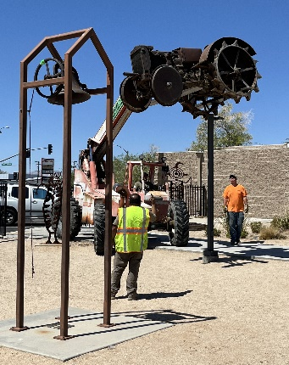
The equipment is part of Dick Lewis’ estate. He came to the Indian Wells Valley in 1936 at the age of 14 to live with Tiny and Earl Standard, early settlers in this area. He purchased the Homestead Restaurant in 1975, where he served delicious meals and a bit of local history complemented by various historic items adorning the walls.
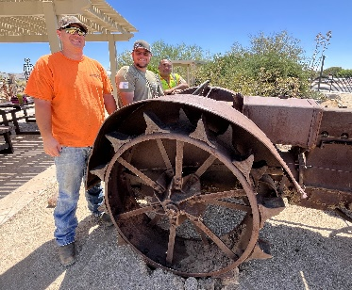
Most of the equipment, including a hay mower, hay rake, and plows, is currently stored near the new curation building. Two large items of interest are easily visible on the grounds: one is a Case tractor located near the Gladys Merrick Garden sign to the east of the main walkway, and the second is a locally made drill rig situated near the water tank, north of the tortoise pens.
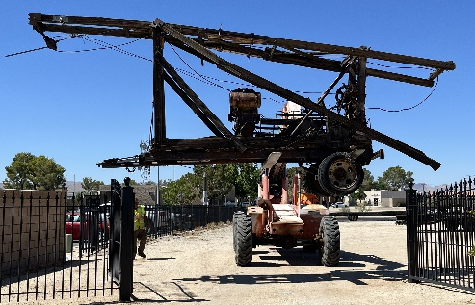
We are very grateful to Rosser Incorporated, a heavy-haul trucking company based in Ridgecrest, for transporting four large items that were too big and heavy for museum volunteers to handle. Chet and Michael Rosser, along with Antonio, spent many hours transporting the Case tractor, the drill rig, a hay wagon, and a railroad cart. Moving the old equipment from the tight, enclosed area at the fairgrounds required significant experience, time, and patience by the Rosser team. Moving the items onto the museum grounds required skilled logistics and teamwork. They used their massive forklift to lift the items over the fence since the items were too wide to fit through the gates. Quite a feat!
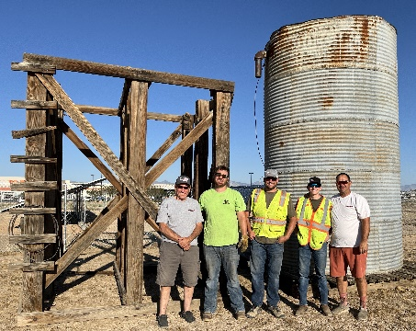
As a side note, the water tank mentioned above was donated to the Maturango Museum by the Clay-Lora Ranch in memory of Clayton and Jewel Schwab, as well as Jessie and Goldie Scroggins, in 2024. The original location of the water tank was northwest of the intersection of China Lake Boulevard and Ridgecrest Boulevard, near Balsam Street. This water tank can be seen in an aerial photograph from around 1945. In 1946 or 1947, the tank was sold to the Clay-Lora Ranch, where it was used for many years. The water tank itself stands approximately 15 feet tall, and the wooden stand is about the same height.
We needed someone with experience to move the water tank, and local businessmen recommended that we contact Rosser Incorporated. Brandon Rosser assessed the situation, devised a safe way to move the tank and its stand, and transported them to the museum. Thanks to their professionalism and attention to detail, we now have multiple historic items on display at the Maturango Museum for people to enjoy!

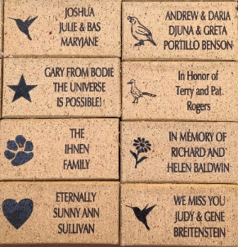
Buy a Brick is Back!… Missed it last time?

Now’s Your Chance.

The QR code takes you directly to Maturango’s Fundraising Brick’s online ordering. On this webpage you will find a quick video and the printable flyer with mail in order form.

This Brick Campaign ends on December 31, 2025. Thanks!
https://maturango.org/fundraising-bricks/

Another! Kern Plateau Meadows Field Trip with Anne Dumas
Saturday August 9

Let's head to the high country! Join the Maturango Museum on a tour of several meadows on the Kern Plateau.
The Kern Plateau is a relatively flat area between 7,500 and 8,500 feet in elevation. There are about 30 meadows with streams and rich soil abundant with plants and flowers. Some years, there are lots of frogs!
It will be fun to explore in the cool mountain air. The meadows we could visit include: Troy, Paloma, Bonita, Boone and perhaps the Bald Mt. Lookout.
Meet at the museum at 7am. You will be required to sign a liability waiver. All ages of participants are encouraged to attend, including well behaved dogs (on a 6' leash).
Buy tickets on the museum website maturango.org/events The cost is $35 for museum members ($60 for 2 members), $45 nonmembers ($80 for 2). Kids under 18 are free.
Cancellation Policy: If the Museum cancels your trip, you will be given a full refund or you may transfer the money to a different trip. No cash refunds will be given if you cancel.
Carpooling is encouraged, but not required. For those driving, be sure your vehicle is in good repair and that it has a full tank of gas. We will be driving nearly 200 miles round trip on our day long adventure. We will return to the museum in the evening. (Or, you could drive up and over Sherman Pass and head home through Kernville.)
Be sure to bring a picnic lunch, plenty of water and a folding chair. Once we pass the Kennedy Meadows General Store, there is no place to buy food or drinks. Sturdy shoes and a hiking pole are strongly suggested.

Maturango Museum
of the IWV
100 E. Las Flores Ave., Ridgecrest, CA 93555
Open Mon - Sat 10 am – 5 pm
Sunday noon – 4pm (except major holidays)

Businesses and Organizations

Supporters • Contributors • Sponsors
AltaOne Federal Credit Union
Ashley Furniture HomeStore
Beanster’s Espresso
Boulder Creek RV Resort
Clarion Inn
Earth Landscaping
Eastern Sierra Custom Framing
Epsilon Systems Solutions, Inc.
Oasis at Death Valley
Gary Charlon State Farm
Heritage Inn & Suites
Hampton Inn & Suites
High Desert Haven
Historical Society of the Upper Mojave Desert
IWV Self Storage
Law Offices of Phyllis M. Hix
McDonald’s Restaurant
Meith Operational Solutions
Michael’s Certified Air
New Directions Technologies, Inc.
Oasis Garden Club
The Car Wash
The Pizza Factory
Red Rock Books
Ridgecrest Area Convention
and Visitors Bureau
Saalex Corp.
St. Ann Catholic School
Searles Valley Minerals
Sierra Sands Unified School District
Sinclair Legal Counsel
Sinclair Tax Service
SpringHill Suites by Marriott
Stafford’s Pest Control
The Swap Sheet
TJ Frisbee Bicycles, Inc
T&T Alignment, Inc.
Vaughn Realty
WACOM
Warren’s Automotive

Staff
Debbie Benson, Museum Director
Maureen Goff, Store Manager/Buyer
Barbara Bane, M.A., RPA, Archaeology Curator
Nadia Mohsen, Curation Technician
Elaine Wiley, History Curator
Sherry Brubaker, Natural History Curator
Andrea Pelch, Art Gallery Coordinator,
Newsletter Editor
Nora Nuckles, Education Coordinator,
Museum Assistant
Linda Saholt, Membership, Donations
Leslie Layfield, Accounting Bookkeeper
Heidi Farmer, Accounting
Addie Reyes, Website
Nick Rogers, Museum Assistant
Barbara Ingle, Museum Assistant

Committee Chairpersons
Elaine Wiley, Publications
Bob Westbrook, Strategic Planning
Bev Hill, Gardens

Board of Trustees
Robert McGowan – President
Patty Wharton – Vice-president
Diane Foucher - Secretary
Jann Philpott - Treasurer
Dan Burnett
Peggy Chun
Alisha Mondragon
Howard McCauley
Dorie Cornell

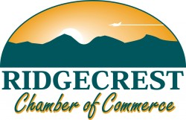

Upcoming and Ongoing Events
- Free Second Saturday August 9: Desert Safety in the Heat, 11am – 2pm, Decorate sun visors
- Another! Kern Plateau Meadows Field Trip with Anne Dumas, Saturday August 9
- Open Studio Tour applications due August 17
- Warner Graves’ Art Exhibit through August 24
- "Hidden Ridgecrest 5” – Video, Sunday August 31, 2 pm
- Pacific Crest Trail Photo Exhibit: April 21 – September 21

Maturango Museum
100 E Las Flores
Ridgecrest CA 93555
www.maturango.org

August 2025 Newsletter
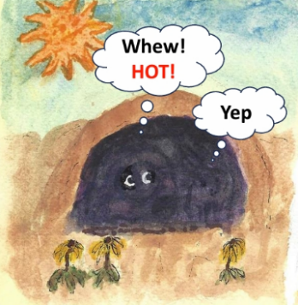
Original watercolor artwork by Carol Dezellem. She is one of our excellent docents.

